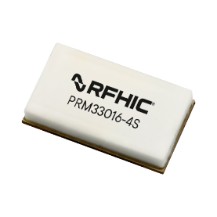

Product Features Applications

3100~3500MHz • Military Radar
- 42.3dBm Output Power @ 14dBm, 3300MHz • Commercial Radar
- 64% Power-added Efficiency @ 42.3dBm
- Large Signal Gain 28dB @ Pin=14dBm
- Internally 50ohm Matched
- GaN on SiC Technology

Description



Package Type : PP-3G

The PRM33016-4S is a fully integrated GaN Hybrid power amplifier module designed for applications in S-band military and commercial Radar Systems covering 3100~3500MHz. The PRM33016-4S provides 28dB of large-signal gain and 64% power added efficiency while achieving over 16W of saturated output power. The PRM33016-4S is matched to 50 ohms with integrated DC blocking capacitors on both I/O ports. This device's size is 8x14x2.6mm and is packaged in a ceramic surface mount package.
Lead-free and RoHS compliant.

Typical Performance (VDS= +24V, TC=25℃, 50Ω)

 | Parameter^{*1}
Frequency [MHz] | Saturated Power [W] | Output Power [dBm] @ Pin = 14dBm | Power Added Efficiency [%] @ Pin = 14dBm | Large Signal Gain @Pin =14dBm
3100 | 16.4 | 42.1 | 64.7 | 28.1
3300 | 17.8 | 42.4 | 66.2 | 28.4
3500 | 17.5 | 42.4 | 64.8 | 28.4

Note

*1 Measured in the PRM33016-4S test board amplifier circuit, under Pulsed CW @ Pulse Width 200 usec, Pulse Period 1 msec

Absolute Maximum Ratings

Rating | Symbol | Value | Unit | Condition
Drain to Source Voltage | VDSS | 100 | V | Tc=25℃
Gate to Source Voltage | VGS | -10, +2 | V | Tc=25℃
Operating Voltage | VDD | 52 | VDC
Storage Temperature | TSTG | -40, +125 | ℃
Case Operating Temperature | T_{C} | -35, +85 | ℃
Operating Junction Temperature^{*1} | T_{J} | 225 | ℃
Soldering Temperature^{*2} | T_{S} | 250 | ℃
Note
*1 Continuous use at maximum temperature will affect MTTF.
*2 Refer to the Application Note(AN-002) on soldering - "Solder Condition for RFHIC's GaN Device"

Electrical Characteristics*1 (T =25℃ unless otherwise noted)
C
Characteristics | Conditions |  | Symbol | Min | Typ | Max | Unit
DC Characteristics (Main)
Maximum Forward Gate Current | Tc= | 25℃ | IGMAX | - | - | 5 | mA
Maximum Drain Current^{*2} | Tc= | 25℃ | IDMAX | - | - | 3.2 | A
Power Dissipation | Tc= | 85℃ | PDMAX | - | - | 29.8 | W
Gate Threshold Voltage | V_{DS} = | 10V | VGS(TH) | -3.80 | -3.00 | -2.30 | VDC
Gate Threshold Voltage | I_{D} = | 5.2mA
Gate Quiescent Voltage | V_{DS} = | 24V | VGS(Q) | -3.75 | -2.80 | -2.25 | VDC
Gate Quiescent Voltage | I_{D} = | 80mA
Drain-Source Breakdown Voltage | V_{GS} = | -8V | VBR | 150 | - | - | V
Drain-Source Breakdown Voltage | I_{D} = | 5.2mA
Saturated Drain Current^{*3} | V_{DS} = | 6V | IDS | 4.2 | 5.2 | - | A
Saturated Drain Current^{*3} | V_{GS} = | 2V
Gate Leakage Current | V_{GS} = | -8V | IGLKG150 | -1.6 | - | - | mA
Gate Leakage Current | V_{DS} = | 150V
Drain Leakage Current | V_{GS} = | -8V | IDLKG150 | - | - | 2.1 | mA
Drain Leakage Current | V_{DS} = | 150V
DC Characteristics (Drive)
Maximum Forward Gate Current | Tc= | 25℃ | IGMAX | - | - | 1 | mA
Maximum Drain Current^{*2} | Tc= | 25℃ | IDMAX | - | - | 0.8 | A
Power Dissipation | Tc= | 85℃ | PDMAX | - | - | 8 | W
Gate Threshold Voltage | V_{DS} = | 10V | VGS(TH) | -3.80 | -3.00 | -2.30 | VDC
Gate Threshold Voltage | I_{D} = | 1.2mA
Gate Quiescent Voltage | V_{DS} = | 24V | VGS(Q) | -3.75 | -2.80 | -2.25 | VDC
Gate Quiescent Voltage | I_{D} = | 40mA
Drain-Source Breakdown Voltage | V_{GS} = | -8V | VBR | 150 | - | - | V
Drain-Source Breakdown Voltage | I_{D} = | 1.2mA
Saturated Drain Current^{*3} | V_{DS} = | 6V | IDS | 0.8 | 1.1 | - | A
Saturated Drain Current^{*3} | V_{GS} = | 2V
Gate Leakage Current | V_{GS} = | -8V | IGLKG150 | -0.4 | - | - | mA
Gate Leakage Current | V_{DS} = | 150V
Drain Leakage Current | V_{GS} = | -8V | IDLKG150 | - | - | 0.5 | mA
Drain Leakage Current | V_{DS} = | 150V

Note

*1 Measured on wafer prior to packaging.
*2 Current Limit for long term, reliable operation
*3 Scaled from PCM data.

Electrical Characteristics*1 (T =25℃ unless otherwise noted) - continued
C
Characteristics | Conditions | Symbol | Min | Typ | Max | Unit
 | RF Characteristics | (Operating Frequency Range)
Output Power @ Pin=14dBm^{*1,} ² | Frequency = 3.1GHz | POUT |  | 42.1 |  | dBm
Output Power @ Pin=14dBm^{*1,} ² | Frequency = 3.3GHz | POUT |  | 42.4 |  | dBm
Output Power @ Pin=14dBm^{*1,} ² | Frequency = 3.5GHz | POUT |  | 42.4 |  | dBm
Power Added Efficiency @ Pin=14dBm^{*1,} ² | Frequency = 3.1GHz | η |  | 64.7 |  | %
Power Added Efficiency @ Pin=14dBm^{*1,} ² | Frequency = 3.3GHz | η |  | 66.2 |  | %
Power Added Efficiency @ Pin=14dBm^{*1,} ² | Frequency = 3.5GHz | η |  | 64.8 |  | %
Large Signal Gain^{*1,} ² | Frequency = 3.1GHz | G_{P} |  | 28.1 |  | dB
Large Signal Gain^{*1,} ² | Frequency = 3.3GHz | G_{P} |  | 28.4 |  | dB
Large Signal Gain^{*1,} ² | Frequency = 3.5GHz | G_{P} |  | 28.4 |  | dB
Duty Cycle | Operating Freq. Range | DC |  | 20 | 30 | %
Pulse Width | Operating Freq. Range | PW |  | 200 | 500 | μs
Amplitude Pulse Droop | Operating Freq. Range | Droop |  | 0.3 | 0.5 | dB
Rise Time | Operating Freq. Range | t_{r} |  | 20 | 100 | ns
Fall Time | Operating Freq. Range | t_{f} |  | 20 | 100 | ns

Note

*1 Pulse width 200μsec, Pulse period 1msec.
*2 Measured in the PRM33016-4S test board amplifier circuit, biasing Drive : ΔVgs-d = -0.5V at Idq 40mA, Main Idq : 80mA
* Above electrical specifications are measured by connecting electrolytic condenser 470μF to V_{DS}. Please make sure that electrolytic condenser is connected properly while testing the PAM.

Block Diagram
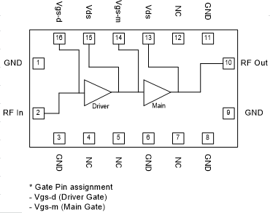
Test Board Component Layout with Coin Embedded

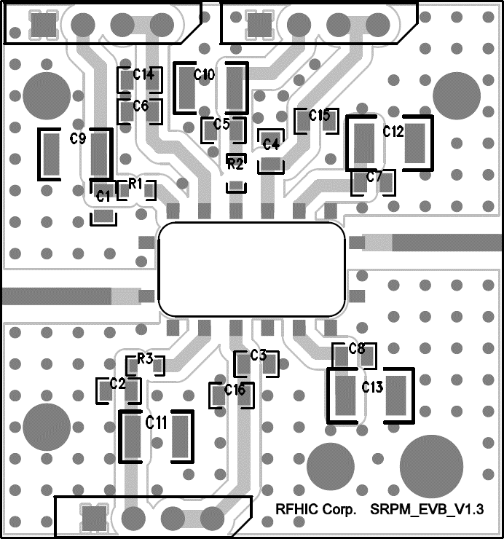
PAM

Part | Description | Part Number | Manufacturer
C4, C6, C14, C15 | 1.0uF / 100V | GRM21BC72A105KE01 | MURATA
R1, R2 | 0ohm, 1608, 0.1W, 50V, -55~155°C | MCR03 EZP0000 | ROHM
PCB | 2Layer, 20mil, 1oz | RO4350B | ROGERS
CON1~2 | 2.54mm Male Connector | 5267-04A | MOLEX
SMA1~2 | Female Connector | - | -
PAM | GaN Hybrid PAM | PRM33016-5S | RFHIC

Package Dimensions (Type:PP-3G)

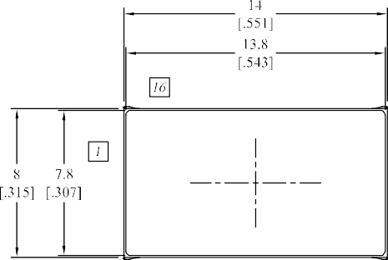
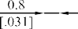Unit: mm[inch] | Tolerance: ±0.15[.006]

Pin Description
2 | 4 | 5 | 10 | 13 | 14 | 15 | 16
RF In | - | - | RF Out | VDS | VGS-m | VDS | VGS-d
- | - | - | - | Main | Main | Drive | Drive
- Other Pins are GND.

Recommended Footprint & Coin Embedded

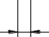Package Outline

3.4
[.134]
1.8
[.071]

Via Hole O 0.3
[.01]

2
[.079]

0.8
[.031]
Coin Embedded 11.6x 5.6 / R1.0

ESD Sensitivity Ratings
ANSI/ESDA/JEDEC Standard JS-002
C2
CDM
ANSI/ESDA/JEDEC Standard JS-001
1C
HBM
Standard
ESD Class

Packing Information
600 pcs on a 13" reel (Standard)
PRM33016-4S
Description
Part Number

Lot Number Description

2 | 5 | 1 | 4 | 0 | 1
① | ② | ③ | ④ | ⑤ | ⑥

①② Year Number
③④ Week Number
⑤⑥ Production Number

Revision History

Part Number | Release Date | Version | Description | Data Sheet Status
PRM33016-4S | Sep, 2026 | 0.1 | Initial Release | Preliminary



Certification
This product is manufactured by a company that is certified for the AS9100D quality management system.

RFHIC Corporation reserves the right to make changes to any products herein or to discontinue any product at any time without notice. While product specifications have been thoroughly examined for reliability, RFHIC Corporation strongly recommends buyers to verify that the information they are using is accurate before ordering. RFHIC Corporation does not assume any liability for the suitability of its products for any particular purpose, and disclaims any and all liability, including without limitation consequential or incidental damages. RFHIC products are not intended for use in life support equipment or application where malfunction of the product can be expected to result in personal injury or death. Buyer uses or sells such products for any such unintended or unauthorized application, buyer shall indemnify, protect, and hold RFHIC Corporation and its directors, officers, stockholders, employees, representatives and distributors harmless against any and all claims arising out of such unauthorized use. All sales inquiries and support should be directed to the local authorized geographic distributor for RFHIC Corporation. For customers in the US, please contact the US sales team through our website at https://rfhic.com/rfhic-us/. For all other inquiries, please contact our international sales team through our website portal at https://rfhic.com/contact/

